Beacon Specification

1. The beacon is acting as a BLE peripheral
2. The mobile phone is acting as a Central device

Beacon structure

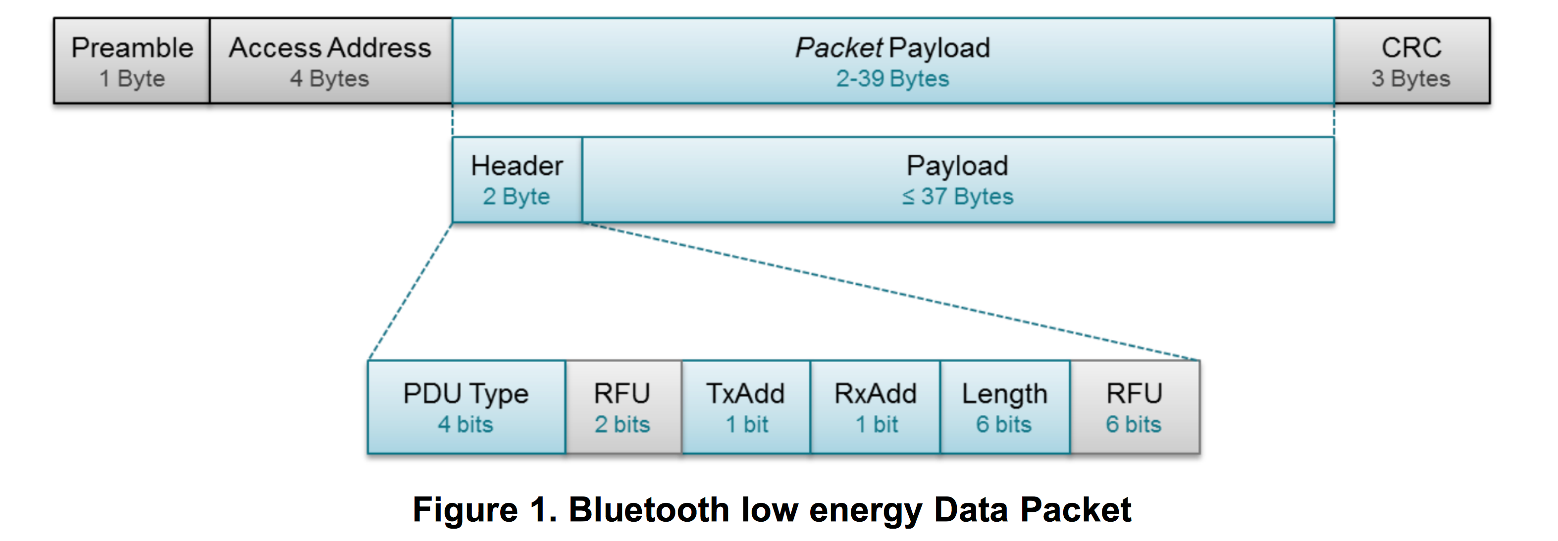

PDU Type : 0010 -> Non-connectable undirected advertising event

TxAdd : 1 -> public address

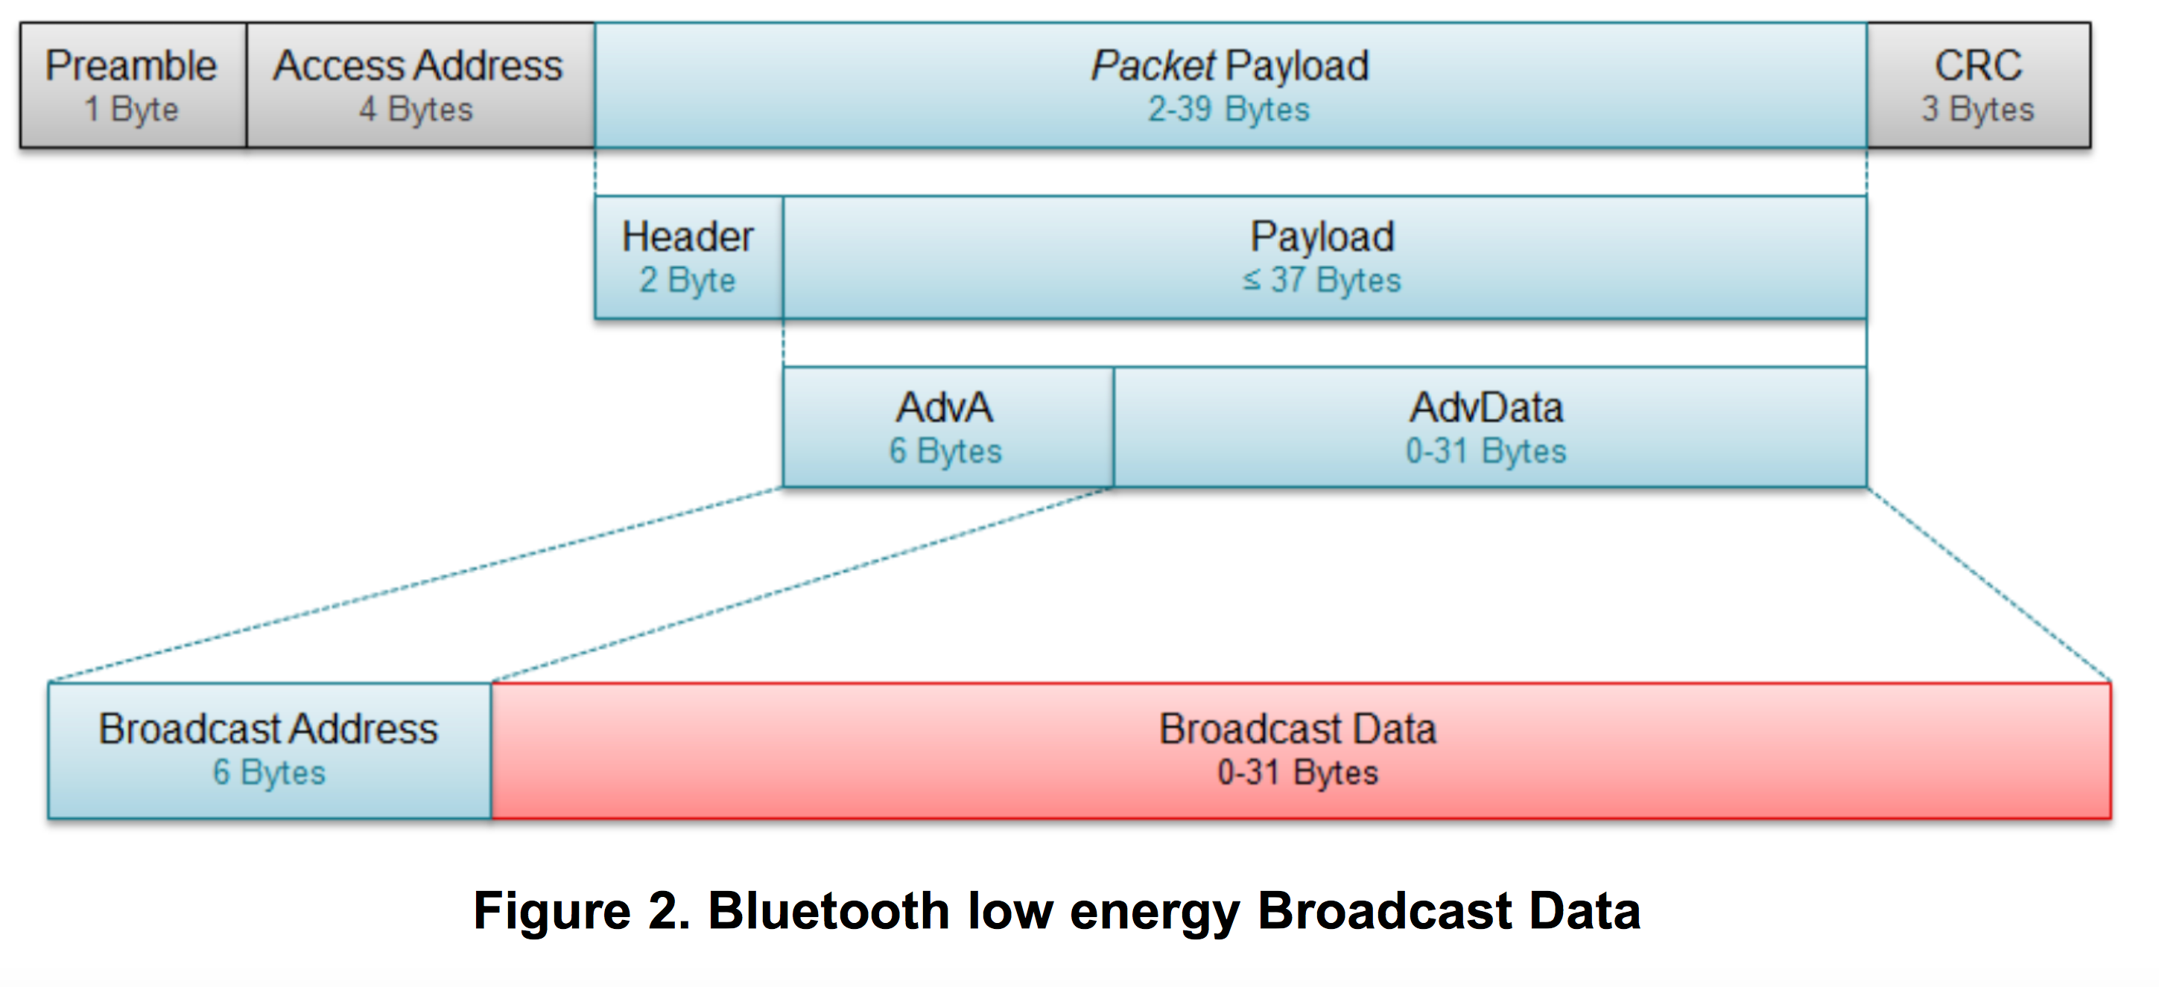

Broadcast Address : MAC Adress (unique id of the beacon)

Broadcast data : complying with http://altbeacon.org/

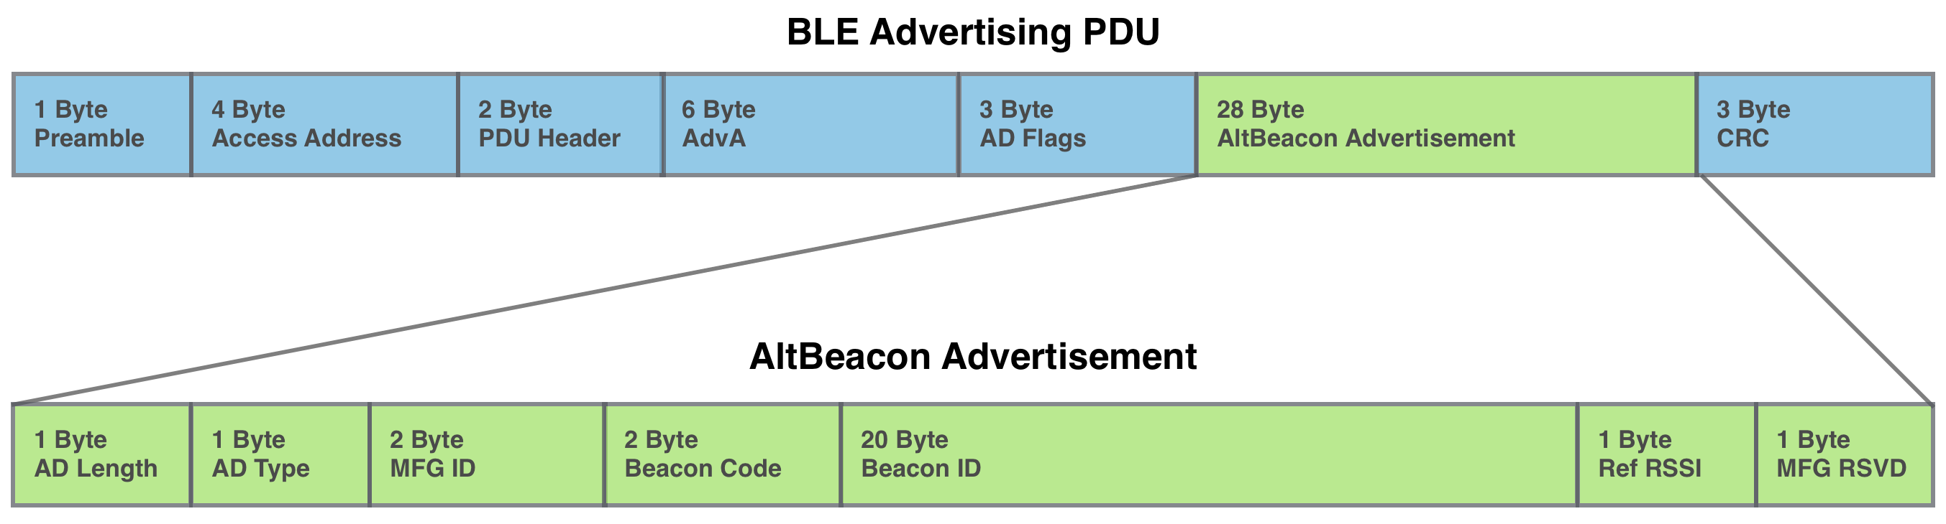

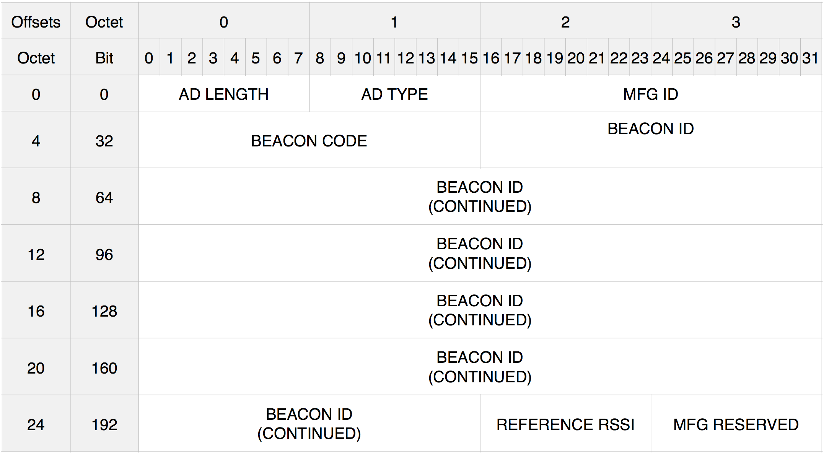

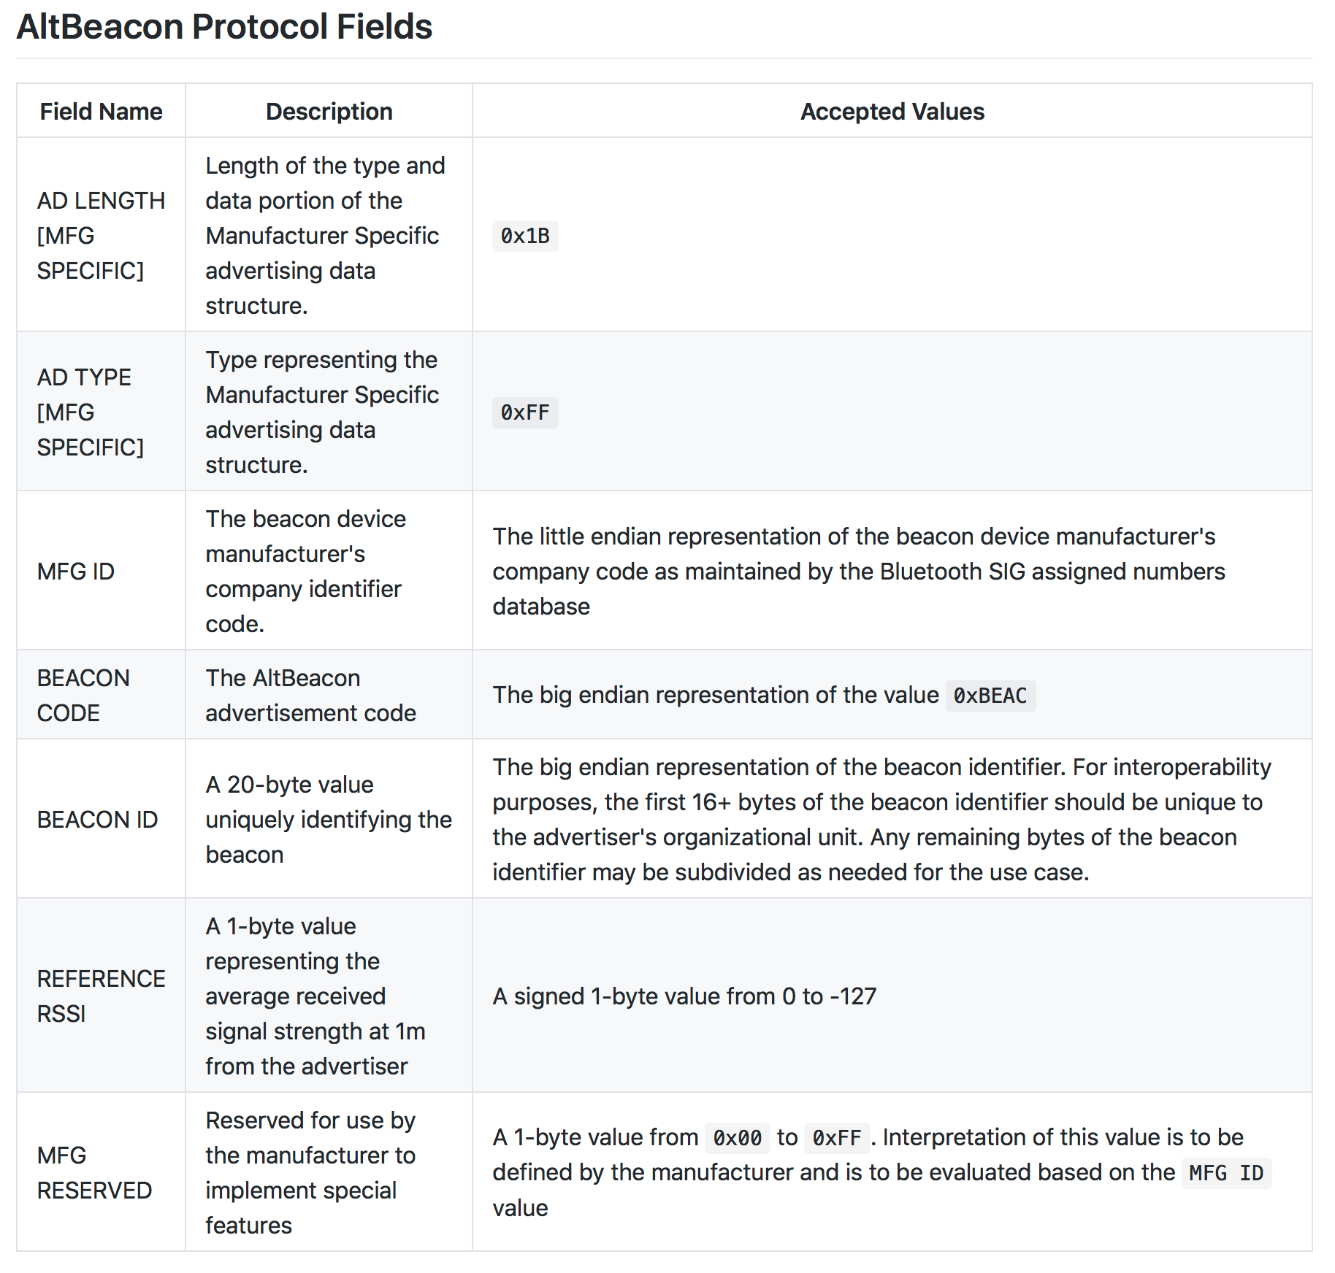

Message payload

Our specific message is delivered as part of the 20-byte value of the BEACON ID :

The contents of the time and calendar registers are in the binary-coded decimal (BCD) format

Year : 1 byte (0-99)

Month : 1 byte (1-12)

Date : 1 byte (1-31)

Day : 1 byte (1-7)

Hours : 1 byte (00-23)

Minutes : 1 byte (00-59)

MAC (Message Authentication Code)

Key is unique and associated with the Beacon MAC address

To be further defined

